1. Change the current directory to /home/<user>
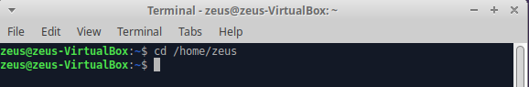

2. Create a directory called systems

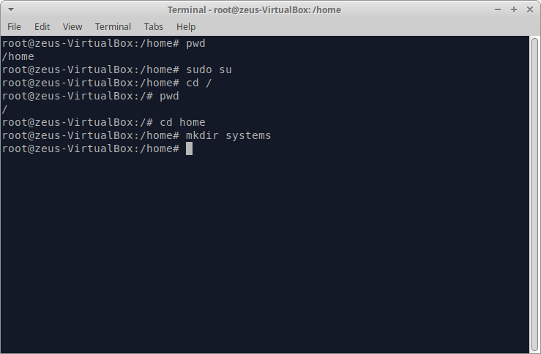

3. Create a directory called exercises. Go to this directory and create another new directory called programming
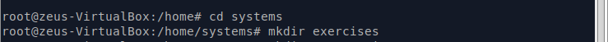
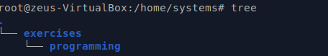
4. Go back to the user’s home directory. Delete the directories “exercises” and
“programming” using just one command. Create the directories again with one
command.
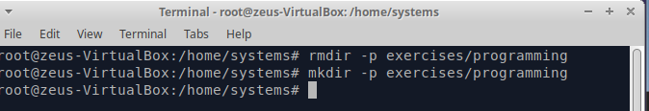
5. Print the contents of the root directory
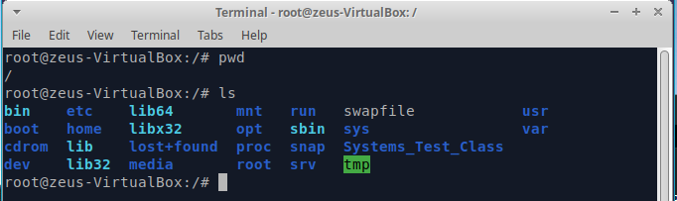
6. Print all the files and directories that begin with d in the /usr/bin directory
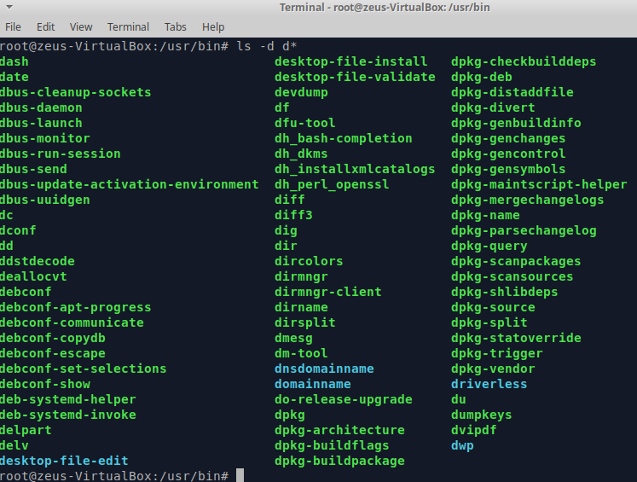

7. List all the files and directories in /etc, including subdirectories
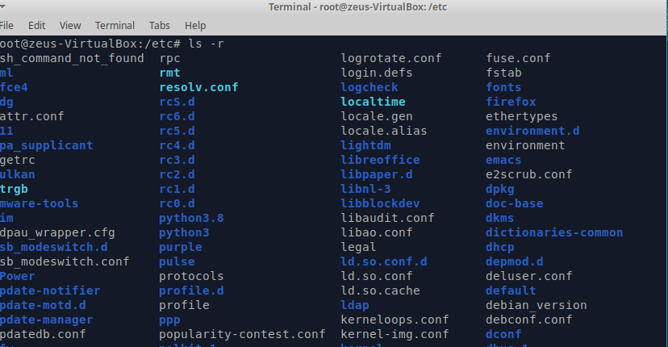

8. Create the empty files called student.txt, student1.txt, student2.txt, list, luggage and last
in the directory named “systems”
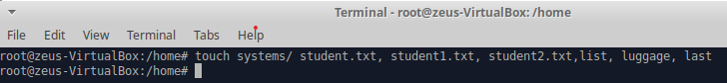
9. Print all the files that begin with “l” in the directory “systems”
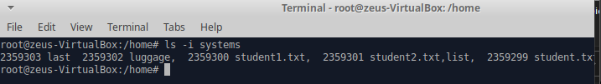
10. Print all the files that end with “txt” in the directory “systems”
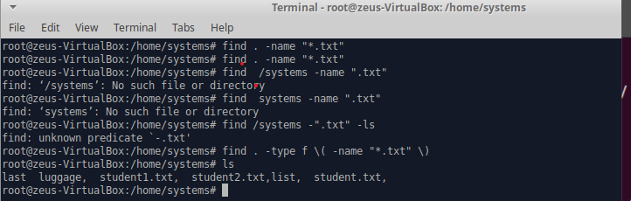
*I did not get it.

11. Create a new directory into $HOME called “config”

12. Copy all the files in /etc which begin with “a” into “config”

13. Delete all the files in “config” which end with “conf”

